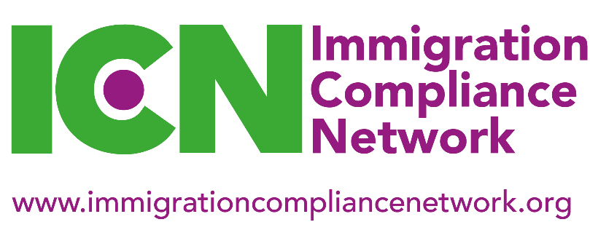
National Workshop, 05 June 2020
Media City UK, University of Salford, Salford Quays, M50 2HE
11am – 3pm (registration from 10.30am)

Booking Form

The Immigration Compliance Network (ICN) is delighted to be holding its June 2020 National Workshop at Media City UK, the University of Salford, Salford Quays, M50 2HE.

The fee for the day is £50 for members and £100 for non-members. Refreshments and lunch will be provided. Members paying the higher institutional membership fee can send up to three colleagues at the members’ rate (and a booking form completed for each attendee). You will receive an invoice for the workshop fee. Refunds will only be given if cancellations are made in writing more than two weeks prior to the meeting. Delegate substitutions can be made at any time without charge.

Please note that ICN events are only open to staff from educational institutions and attendance by staff from other organisations is by special arrangement only.

Name

Job title

Institution

Address
Phone

Email

Please tell us about any dietary requirements you may have

Fee payable  (please highlight) | Member £50 | Non-member £100
ICN membership type  (please circle) | Individual | Institutional
Which regional group do you belong to? | London and South East | Midlands
 | North East | Northern Ireland
 | North West | Scotland
 | South West and South Wales | Yorkshire and Humberside

Please return this form to ICN@ukcisa.org.uk

