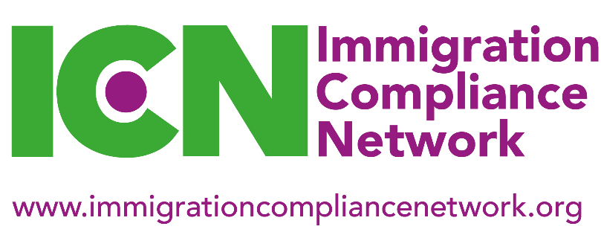
National Meeting, Monday 13 July 2020
10.30am – 3.30pm

Booking Form

The Immigration Compliance Network (ICN) is delighted to announce that we will be holding our Summer 2020 National Meeting virtually. Details of how to join the meeting will be sent in due course but the meeting will be run via Microsoft Teams.

Please note that ICN events are only open to current ICN members who hold either institutional or individual membership. Institutional members can send up to a maximum of three delegates from their institution.

Please be aware that bookings will close on Wednesday 8 July 2020 or once the delegate list reaches 100 sign-ups (whichever is the sooner).

Please note that there will be no charge to attend this national meeting.

Name

Job title

Institution

Address
Phone

Email

ICN membership type  (please tick as app) | Individual | Institutional
Which regional group do you belong to? (please tick as app) | London and South East | Midlands
 | North East | Northern Ireland
 | North West | Scotland
 | South West and South Wales | Yorkshire and Humberside

Please return this form to ICN@ukcisa.org.uk

