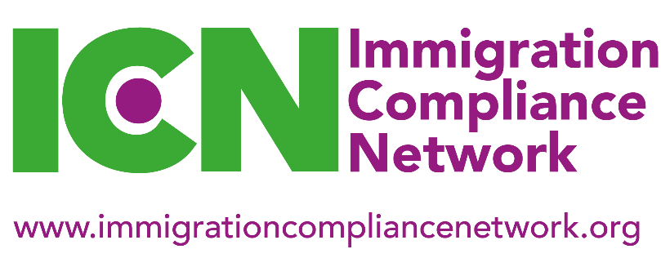
National Meeting, 14 May 2021
10.30am – 3.30pm

Booking Form

The Immigration Compliance Network (ICN) is delighted to announce that we will be holding our Spring 2021 National Meeting virtually. Details of how to join the meeting will be sent with the joining instructions.

Please note that ICN events are only open to staff from educational institutions who are ICN members and have paid their 2020/21 ICN membership. Attendance by staff from other organisations is by special arrangement only. Institutional members can send up to two student compliance delegates and one HR/ worker compliance delegate. Numbers will be capped at 100 student compliance delegates and 40 HR/ worker compliance delegates so please book early to secure your place.

Name

Job title

Compliance area (Student or HR/worker compliance)
Institution

Address
Phone

Email

ICN membership type  (please circle) | Individual | Institutional
Which regional group do you belong to? | London and South East | Midlands
 | North East | Northern Ireland
 | North West | Scotland
 | South West and South Wales | Yorkshire and Humberside

Please return this form to ICN@ukcisa.org.uk

